
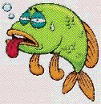
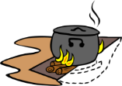

May 17th thru the 19th, 2025
Sunday Serenity Group is Sponsoring
The 9th Annual Fish Fry and BBQ
SATURDAY May 17th 12:00 Noon
WHERE? Westmoreland State Park, VA

Located at Pavilion One – BRING A DISH TO SHARE

Westmoreland State Park, VA

And, The 5th Annual CAMPOUT

Want to Camp Out? Make Your Reservations Today
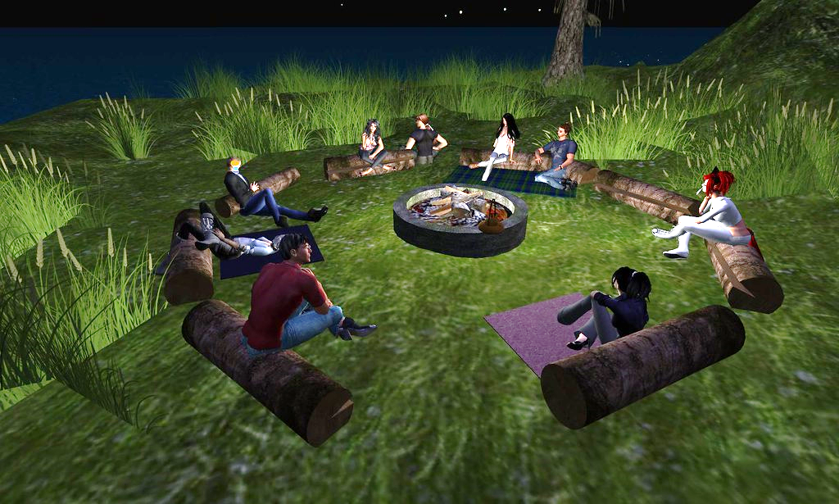
On-Line https://www.dcr.virginia.gov/state-parks/westmoreland#cabins_camping





Come ON--Join the Fun! Meetings, Eating and Greeting

Friday, May 16th
12:00 p.m. Campground Arrival and Set-up
6:00 p.m. Grilled Chicken/Potluck Dinner (Bring a Dish if you Care)
8:00 p.m. Campfire Meeting with some good ole Campfire Fellowship

Saturday, May 17th
8:00 a.m. Campfire Meeting / Coffee Supplied -- Bring your favorite PREPARED Breakfast Dish if you Care
12:00 p.m. 9th Annual Fish Fry & BBQ—Area Pavilion One
Late Afternoon/Early Evening Hot Dog’s & The Fixings (Bring a Dish if you Care)
8:00 p.m. Campfire Meeting with some good ole Campfire Fellowship

Sunday, May 18th
8:00 a.m. Campfire Meeting / Coffee Supplied – Bring your favorite PREPARED Breakfast Dish if you Care
12:00 Noon Check Out of Camp Sites

NEED ADDITIONAL INFORMATION?
Email annualaafishfrycampout@gmail.com and someone will get back to you.
Camping, Hiking, Beach/Water Fun, Chilling and Fellowship!

Meetings, Coffee, Eating & Fellowship
Location Buddy Camp Site C10

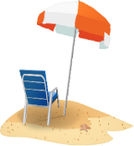
New Site

